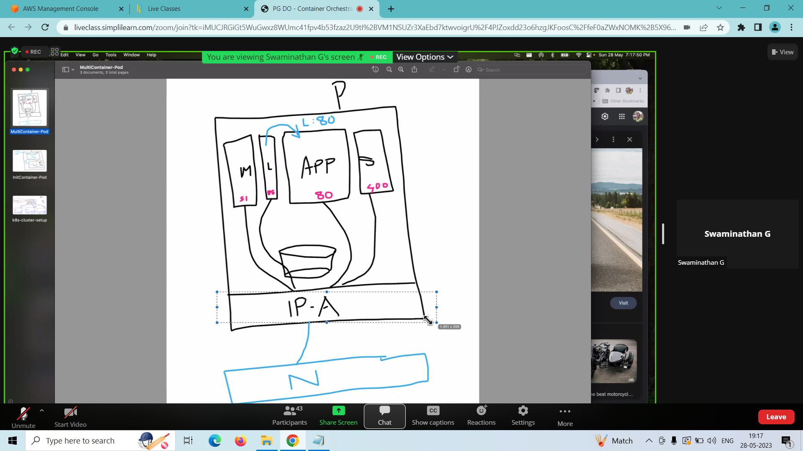

This is a pod with 4 containers :

App is main container and others are side car containers

S – firewall container

M – monitoring container

L – logging container- which is going to pull the logs from the app

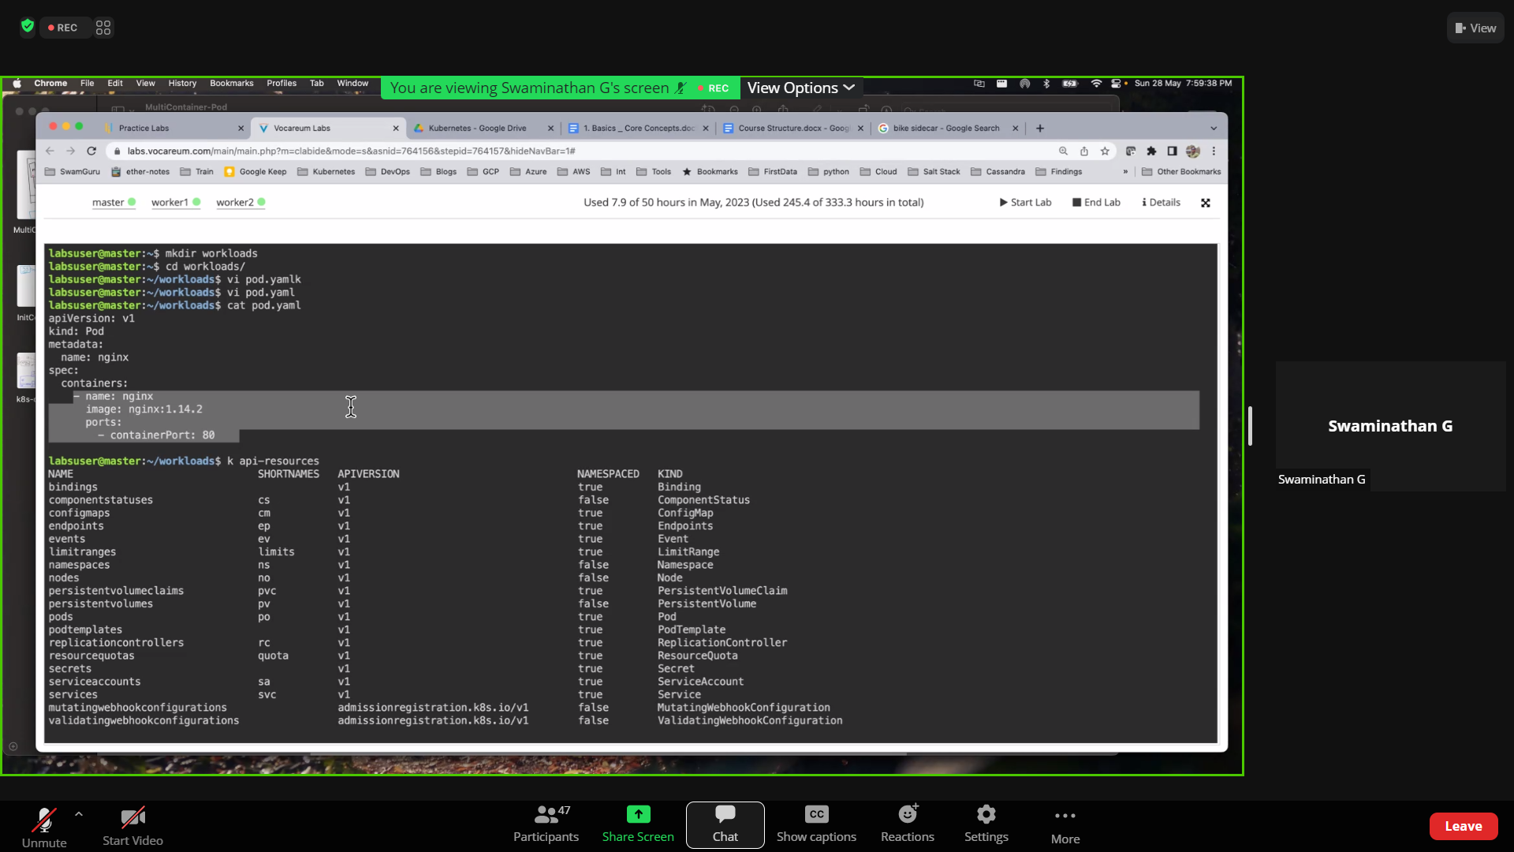

This is a manifests file –

Pod name and container name can be different

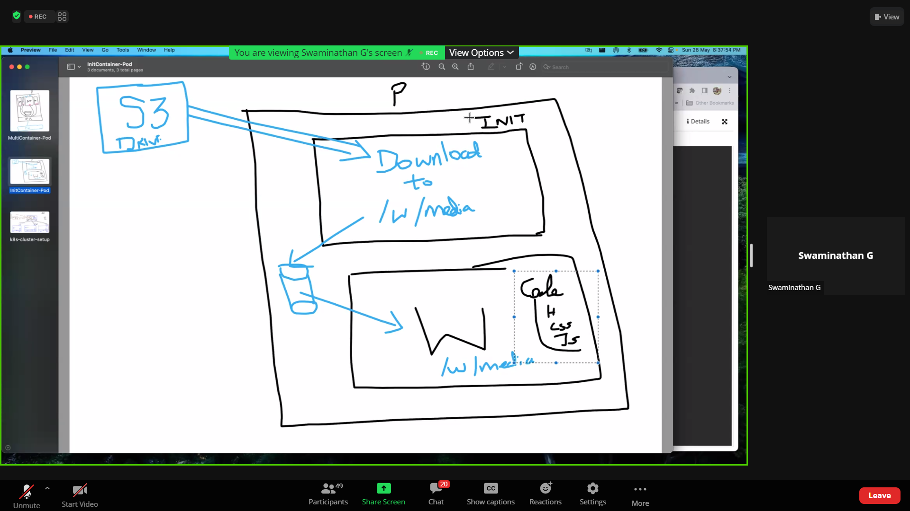

INIT-CONTAINER

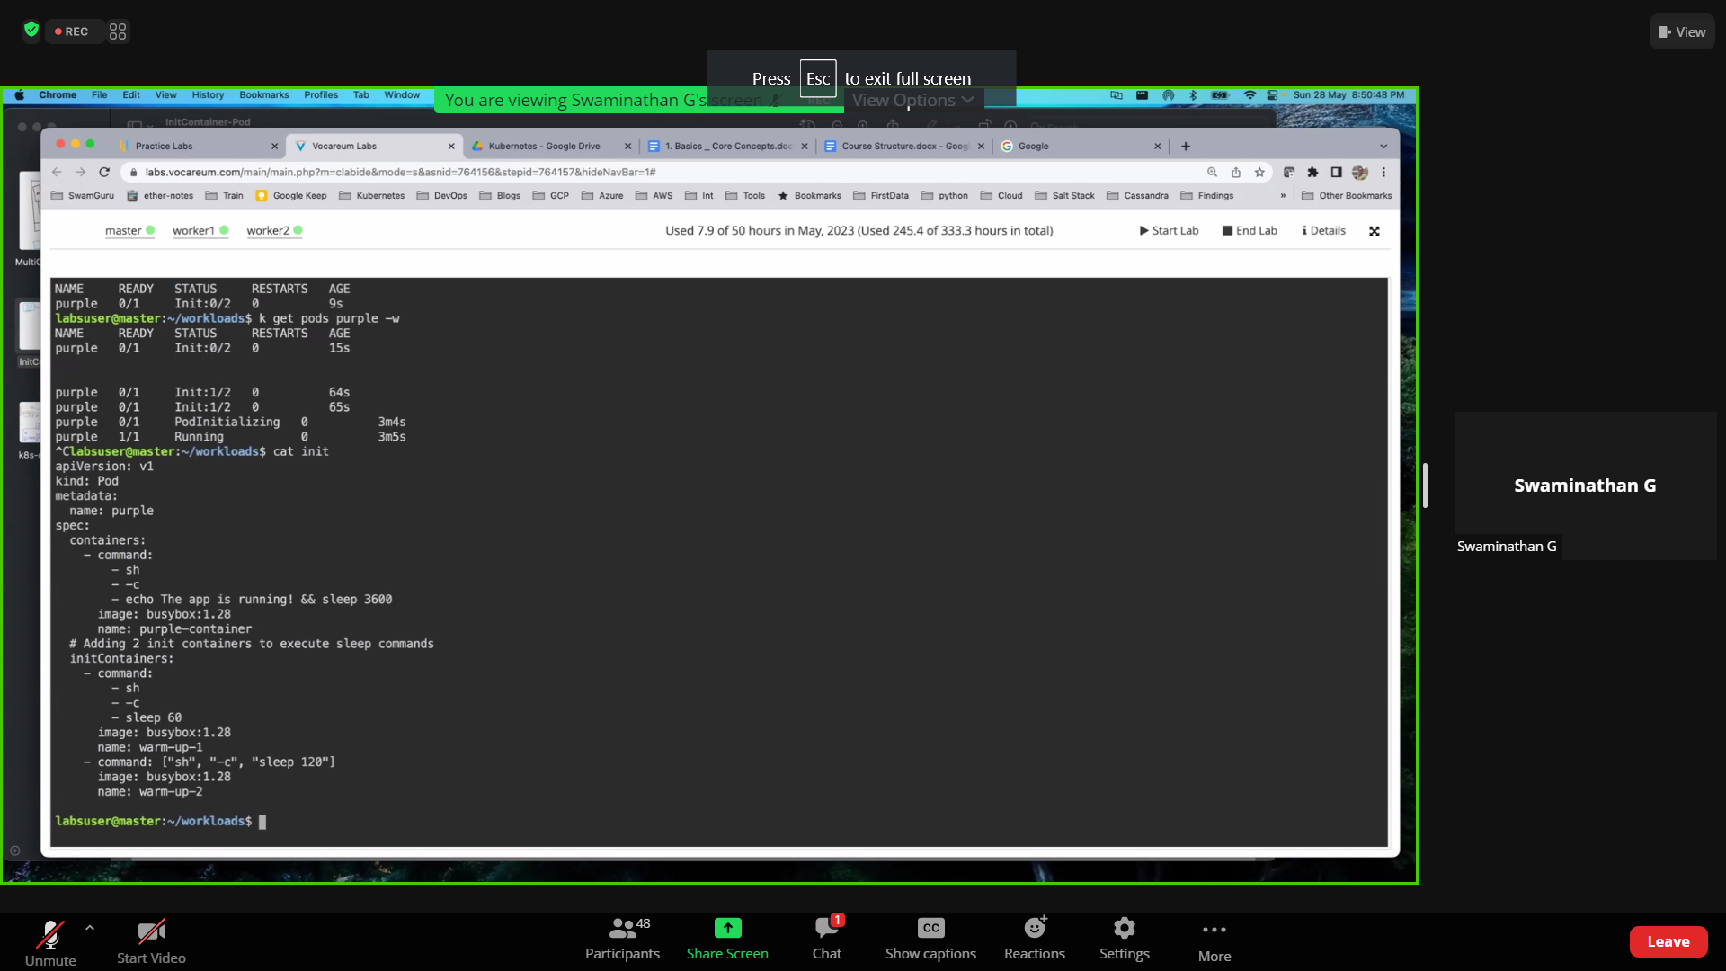

Manifests file for init container

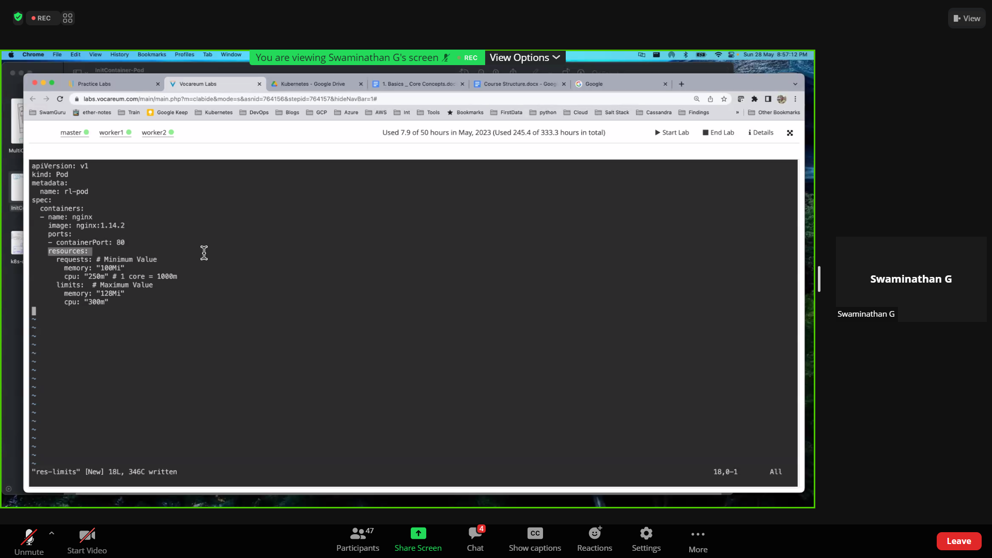

RESOURCE LIMITS :

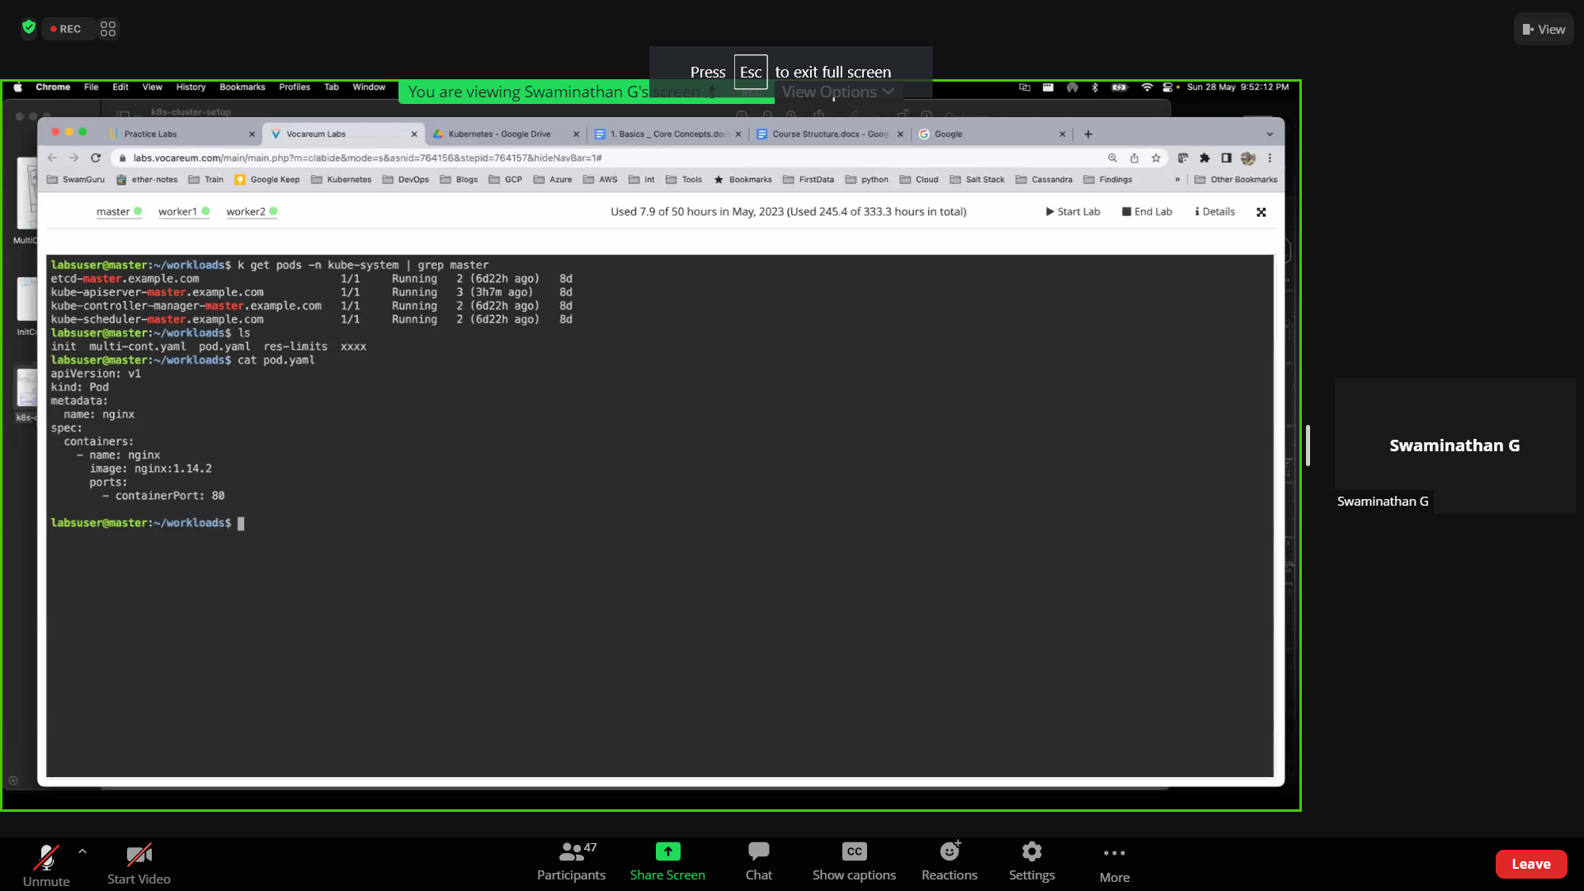

STATIC POD

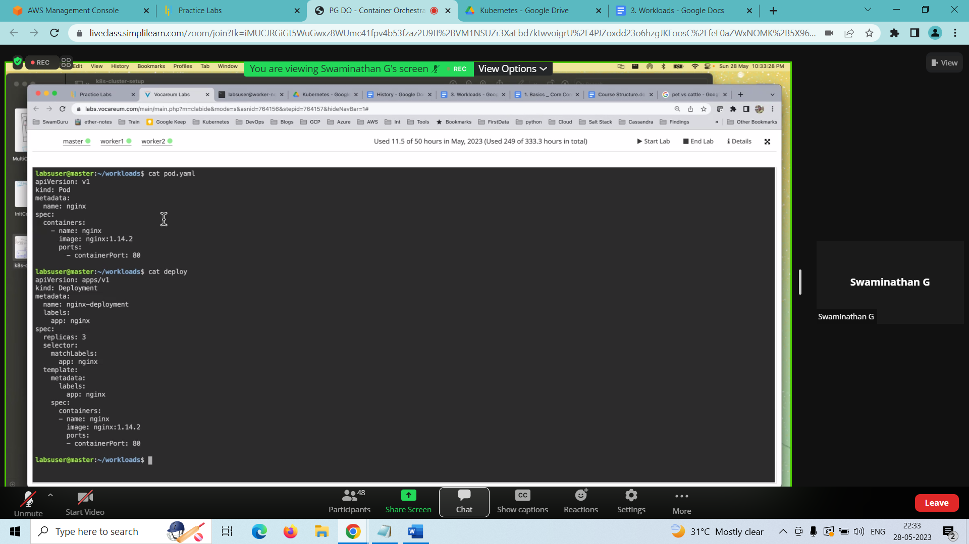

PET VS CATTLE

Pet = pod

Cattle = deployment

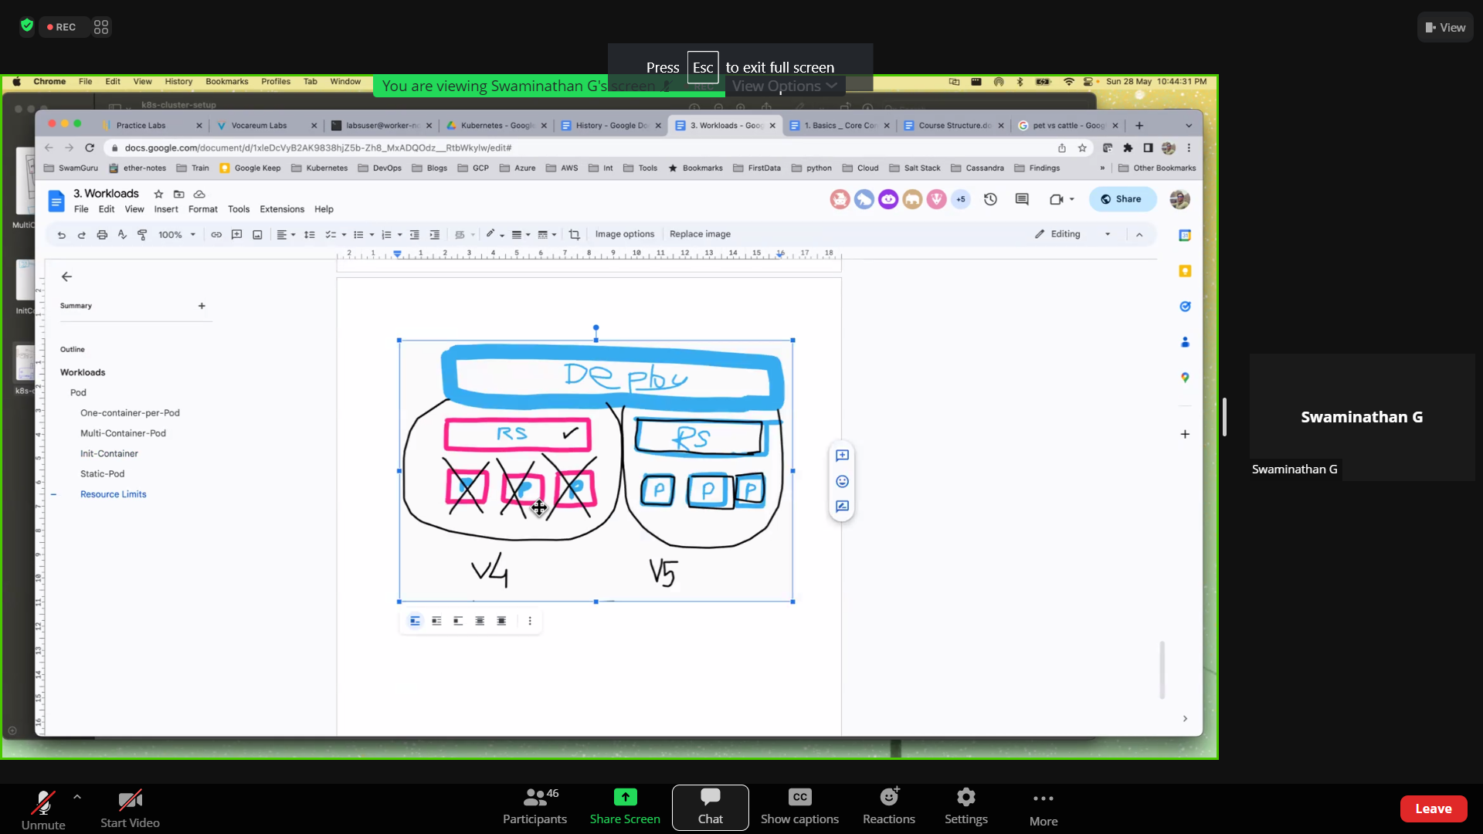

replicaset